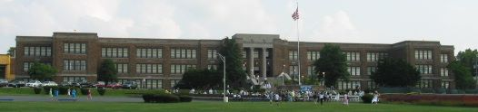

KENNETT HIGH SCHOOL
CLASS OF 1973
40TH CLASS REUNION CELEBRATION

Mark your calendars!! The older we get, the more we realize how short life really is. Where did 40 years go! Come see your “old” friends from high school. Let’s have a record crowd for our 40th! We hope to have some of our favorite teachers join us – get the chance to tell them thank you and how they influenced your life. Have fun dancing and picking your own music on a jukebox from Jukebox John! Enjoy a delicious buffet meal prepared by Capozzoli Catering.

DATE: Saturday, November 30, 2013
TIME: 7p.m. – 11p.m.
PLACE: Red Clay Room (Kennett Fire Company)
423 Dalmation Street
Kennett Square, PA 19348
COST: $50/person - Due by October 15, 2013
Checks payable to - KHS Class of 1973
Mail to – KHS Class of 1973 Reunion
P.O. Box 733
Kennett Square, PA 19348

Questions - contact Kathy Gebhart – kgebhart23@yahoo.com or 610-869-3382.

Reunion Committee – Kathy Brown Gebhart, Donna Ruggieri Hess, Kevin Kendig, Cheryl Baccino McCarthy, Jane Little Mellinger, Janet Musacchio, and Sue Wickersham Torello

